**API -SERVICES**

**BUILD, BUIL, BUILD**

* WHAT WHY, HOW, WHEN.
* PLAN is a map that guilds you find a way to get to your destination.
* Read and Study API documentation contract.
* Schema – json and xml schema validations
* Request message
* Response message
* Client Server architecture.
* Local and Remote computer systems.
* Authentication and Authorization.
* Client User agent – API agent (Postman, CURL, RestAssured, RestClient, and many more).
* 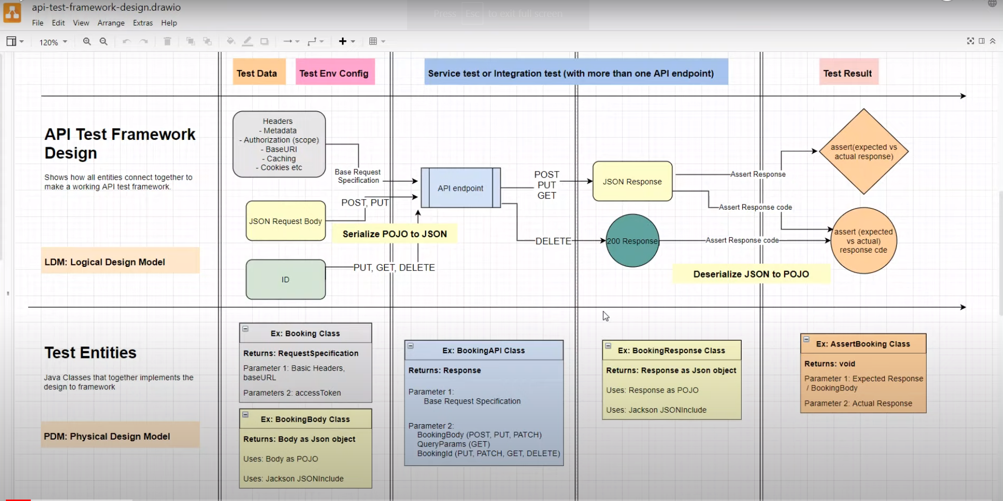

SOAPUI – Services

* WSDL – web service description language.